**Crack the COVID-19 Hackathon**

**Solution Overview and Architecture**

**Team Name :** HashKey

**Team Leader :** Jerry George Jaimon

**Email ID :** [jerryjaimon4321@gmail.com](mailto:jerryjaimon4321@gmail.com)

**Solution Brief Overview**

The solution that we aim to provide for the track of Community Cooperation is a one stop mobile application system called SEVA that acts as an intermediate between the authority and people as well as between the common civilians themselves to procure and share necessary information and resources. This includes the vast yet necessary requirements of volunteering, food and material resources, vital and legitimate news and information and health. Most of the idea is still in its stub and hasn’t been implemented to its completeness due to time limitations, but we’re working on completing this project and making this a reality as soon as possible.

**Solution Description**

One of the biggest issues caused by a sudden halt in the day to day schedule due to such a widespread global pandemic is the lack of medium to communicate within the masses – be it general information or awareness that needs to given attention to. People face an unprecedented form of restriction and it becomes difficult, even for the authorities to find a quick and accessible method to provide resources to the required, employ volunteering as per necessity, keep track of the demand of materials region wise and most importantly – to make information available, even to the grassroot mass.

Taking such a scenario into consideration where community cooperation is of utmost importance, Team Hashkey presents a one-stop assistive intermediate solution to ameliorate the situation – an information and service oriented application called SEVA.

The primary functionality of our app is to provide legitimate news and statistics regarding the current pandemic. We incorporate the news facility to bring out the top COVID news region wise using the NewsAPI connected via the retrofit2 REST API client. With consideration to people that may/may not require sensitive news, we process the news through Tone Analyzer to filter out negative news as per required. We also display the per day , region wise statistic regarding the COVID cases.

Moving on, we provide a platform for people to apply for volunteering with their basic contact details as well as to ask for resources and provide them. We’ve worked on the starter kit provided by IBM for Call for Code 2020. A major conundrum the authorities face is to divide the required resources as per need and to find people to volunteer in this dire time that requires manpower to simplify the working of every sector. Hence, we provide a functionality for people to apply as volunteers, to ask for the required resources to be provided based on the region or nearby camps, and to make their resources available to others by applying for it , which on approval will undergo standard checks by the authority before being delivered. An IBM Watson chatbot instance is added for navigational help. A future functionality we plan to add after initial usage is to collect the demand data for materials, and using that to create a data model – we propose to use ML to predict the required resources of a region for a longer period, so that its easier for the authorities to plan and procure specific resources as per the needs.

Furthermore, we integrate the IBM Watson chat assistant as a general informant regarding the COVID pandemic, the symptoms, precautions, lockdown rules, etc. with existing skills available already. In the future, We plan to add on the facility for the chatbot to recommend nearby hospitals / emergency units using HERE Location API. We also plan to implement the Tone Analyzer here as well to perceive and score the mental well being of the person for the records which could be used by professionals as an individual health record component.

Health is the final component of our service oriented application – a component that’s currently an idea bubble, heavily under maintenance and is purely dependent on resource availability and cooperation from the authorities. We provide the feature for people to create a record of their basic health statistics be it weight, height, last measured Blood Pressure rates, sugar levels etc. to be stored with SHA256 encryption which can be used for remote diagnosis of the person with a health professional over the internet so that we reduce the number of reasons for a person to walk out in this pandemic. A person will be able to mark appointments from government approved doctors willing to provide online diagnosis and share his/her health details with the doctor along with a health score we aim to produce by using the Dacadoo Health Score provided in the IBM cloud catalog. The users can also be provided available information of prescription medicine from available opensource drug databases so as to focus on controlled drug usage. Contact tracing is yet another feature that we aim to implement once we get through to covering up the privacy concerns, using the opensource Contact Tracing APIs provided by Google as well as Apple so as to let people be aware if they’ve ever been in the proximity of a specific health risk.

The reason why such an application would stand out from the existing technologies is that, there hasn’t yet been a popular and central one-stop application that mandates all of these vital features , and there aren’t any that even covers certain features as volunteering. More importantly, all of these features link together to work , is not an overkill for an application, is completely implementable with available technology and the only reason why the project is still a stub is due to the provided time restrictions that was mostly used to learn about the required technology.

**Solution Architecture**

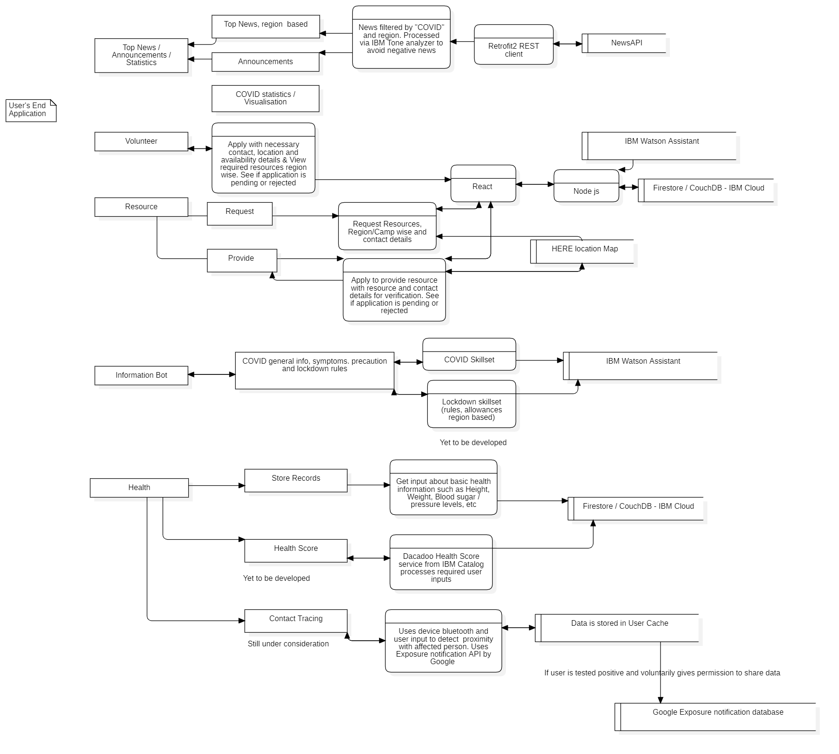



The basic ideation solution architecture (Data flow diagram made with StarUML) is provided with mentions of the technological stack used in each stages. A lot of the ideation is yet to be implemented into the application but the roadmap towards building it has been mentioned in the solution architecture as well as the solution description provided above. The management side of the application available to the authorities would involve verification of user data especially in steps that involve volunteering. Elements that are left for future development once in usage like the use of Machine Learning to predict the resource requirement from the request data and the use of related drug directories have been omitted from the solution architecture so as to await a stable stage in development to be able to implement such features and maintain a complete system. Future plans for upgradation as well as features not yet implemented are mentioned with its plan of action in the solution description.

**IBM Cloud Services / Systems**

This is the technological stack (inclusive of IBM cloud services) that has been implemented and are yet to be planned and implemented for the project :

**IBM Watson Chatbot** for COVID and related information  
**IBM Tone Analyzer** for filtering news based on user requirement  
**IBM Cloud** for hosting the Data   
**Couch DB** as the database hosted in cloudant  
**HERE Location API** for location of resources  
**NewsAPI** for the top headlines and alerts regarding the pandemic   
**Retrofit2 API** as the REST communication client  
**IBM Dacadoo** for Health Score  
**Contact Tracing (Exposure Notification) API** by Google (for Android)  
**IBM Machine Learning** for prediction of demands  
**Java** as the programming language for the application